BJT Amplifier Lab
Seth Ricks
ECEN 350
11/14/2025

ECEN 350 – BJT Amplifier Lab (50 points)
(jas, BJT Amplifier Lab.docx, 12/28/2024)

Note: You can work in pairs if desired on this lab, although no three person teams are allowed. Submit an electronic version of a lab report to receive credit for doing this lab. The goal of your lab report is to provide sufficient documentation so that the lab can be repeated if necessary. Therefore, simply add to this document to arrive at your lab report, as all of the explanatory text, procedures, and Discussion and Conclusion questions contained in this document are required for a complete lab report. So, for your lab report, add a cover page that includes name or names, class and name of the lab. Also add in your results, and answers to the Discussion and Conclusions questions to the existing lab document. While you are to share all Procedure items with your lab partner if you worked in a pair, your Discussion and Conclusions section is to be uniquely yours and not a copy of your lab partners. See the grading rubric at the end of this document for more details.

Purpose: To construct and characterize a voltage divider biased BJT amplifier employing ac emitter feedback.

Parts and Equipment:
1 – 2N3904 npn transistor.
1 – 120 Ω resistor.
1 – 470 Ω resistor.
1 – 680 Ω resistor.
1 – 2.7 kΩ resistor.
1 – 3.9 kΩ resistor.
1 – 100 kΩ resistor.
1 – 0.1 µF Capacitor
1 – 1 µF, 50 V capacitor.
1 – 10 µF, 50 V capacitor.
1 – 22 µF, 50 V capacitor.
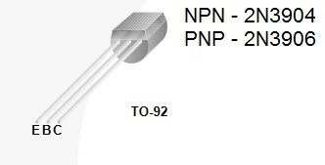
1 – Portable Digital Multimeter (DMM)
1 - VirtualBench Measurement System and Computer.
2 - 1X/10X Probes for the VirtualBench MSO.
1 – BNC to alligator or micro-grabber cable for VirtualBench FGEN output.
1 - Breadboard.
Figure 1: Pin-out for 2N3904 npn transistors.

Solderless Breadboards

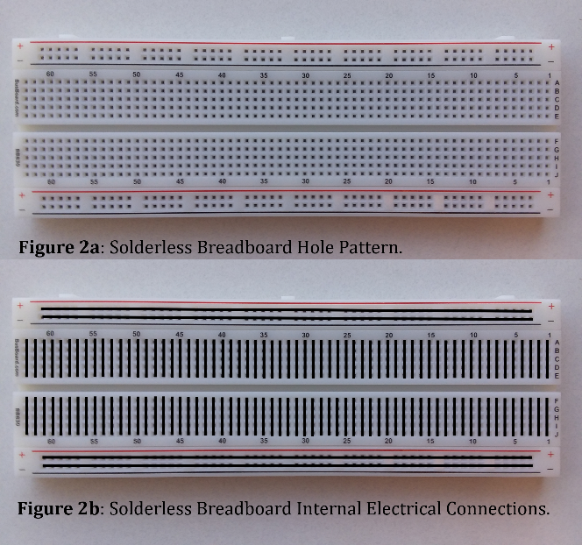
A solderless breadboard is illustrated in Figure 2a, with the rows and columns of holes connected internally as shown in Figure 2b. The two pair of long rows labeled + and – are intended to provide easy access to power and ground. Hence, connecting the external power supply to one of the long rows labeled + and – provides convenient access to power and ground when several power and ground connections are required.

Through-hole components can be inserted and connected in the desired configuration on a solderless breadboard using the internal electrical connections shown in Figure 2b, along with various length hook-up wires illustrated in Figure 3. Try and minimize the length of hook-up wires for better circuit performance. Also, hook-up wires with the stripped and tinned leads produce more reliable circuits than the hook-up wires with the pins on the end. Please do not repurpose the hook-up wires for other projects.
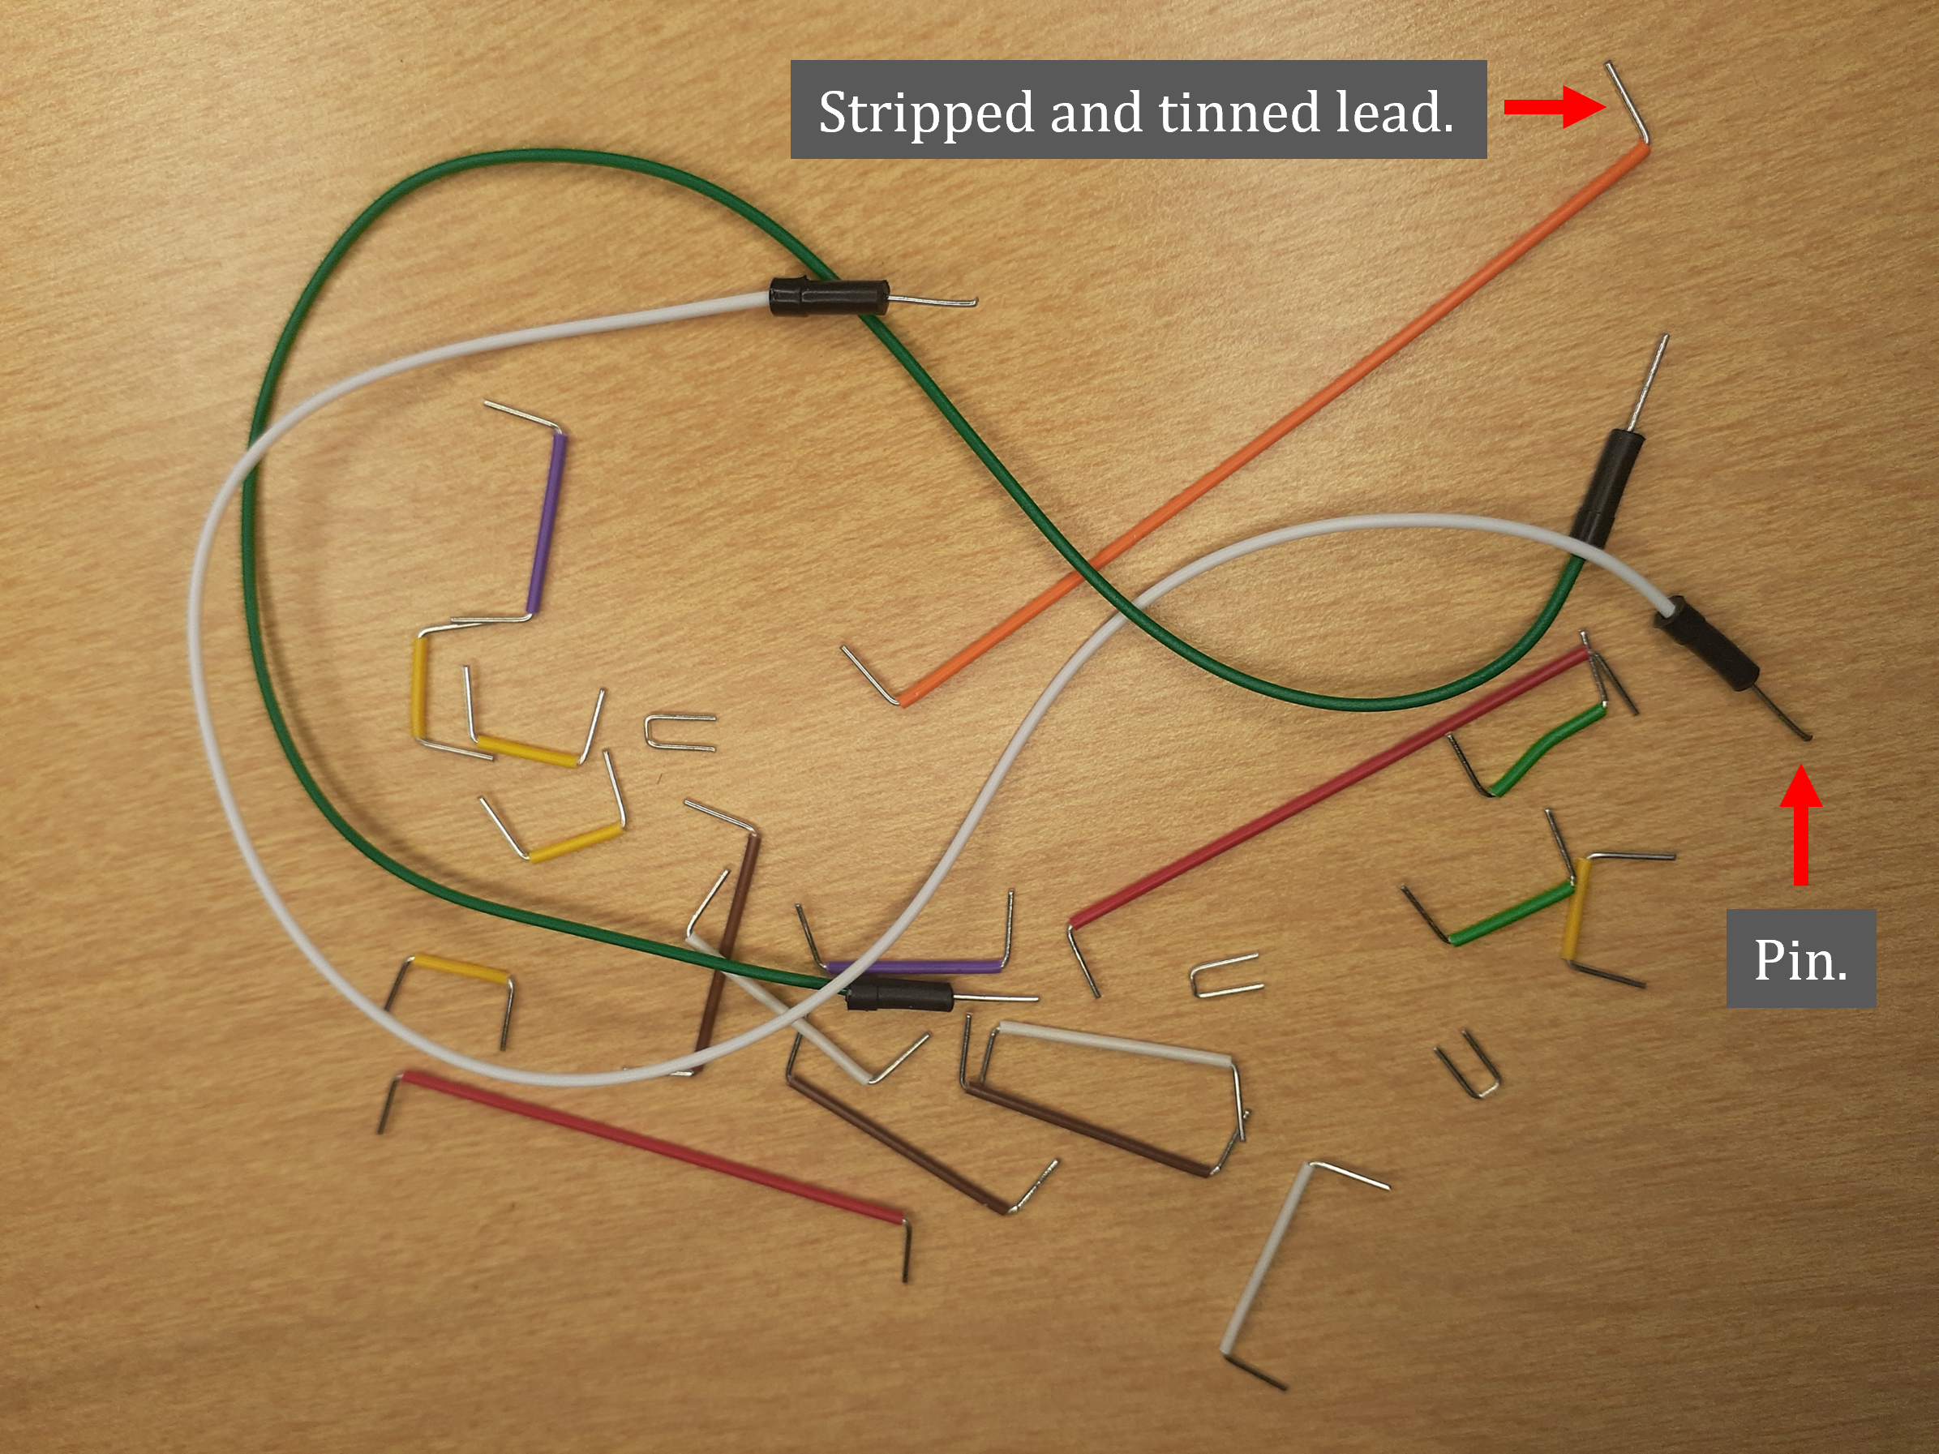
Figure 3: Hook-up Wires for Solderless Breadboards.

Procedure:

Part 1 – Amplifier Hand Calculations.

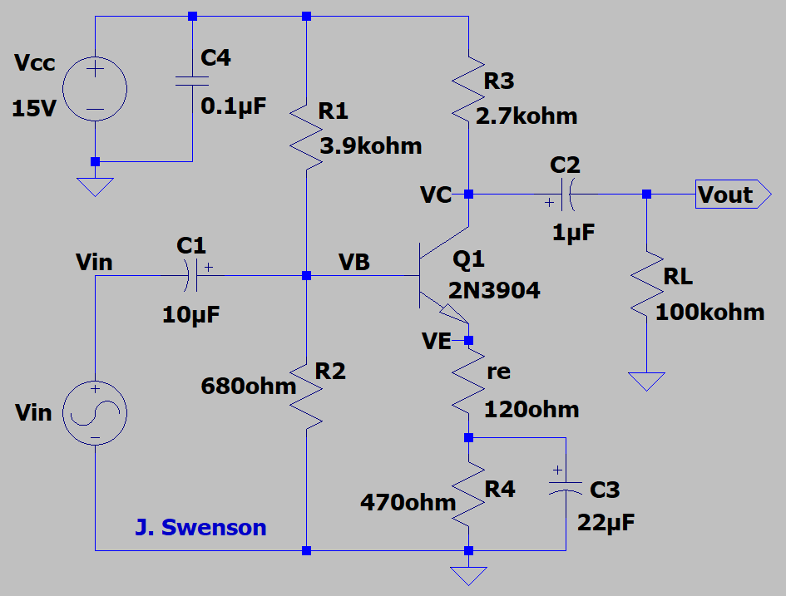
- For the Figure 4 circuit, hand calculate V_{B} using simplified analysis, followed by I_{E}, r_{c}, $r_{e}^{'}$ and A_{V}, along with |A_{v}|_{dB} calculated as 20log₁₀(|A_{v}|), including your results below in Table 1. Note: The ac voltage gain A_{V} is a unitless negative quantity for an inverting amplifier, whereas 20log₁₀(|A_{v}|) is a positive quantity with units of dB.
(12 points.)

Figure 4: BJT Amplifier Circuit to be Analyzed for this Lab.

$$V_{B}=15V\left(\frac{680Ω}{3.9kΩ+680Ω}\right)=2.23V$$
$$I_{E}=\frac{V_{B}-0.7}{r_{e}+R4}=\frac{2.23-0.7}{120+470Ω}=2.59 mA$$
$$r_{c}=R3∥RL=\frac{2.7kΩ*100kΩ}{2.7+100kΩ}=2.63 kΩ$$
$$r_{e}^{'}=\frac{25mV}{I_{E}}=9.64Ω$$
$$A_{v}=-\frac{r_{c}}{r_{e}^{'}+r_{c}}=-\frac{2.64kΩ}{9.64+120Ω}=-20.29$$
$${\left|A_{V}\right|}_{dB}=20\log_{10}\left|A_{V}\right|=20\log_{10}{(20.29)}=26.14$$

Table 1: Small-Signal Model Parameters for the Common-Emitter Amplifier of Figure 1.
V_{B} | I_{E} | r_{c} | $$r_{e}^{'}$$ | A_{v} | |A_{v}|_{dB}
2.23 V | 2.59 mA | 2.63k$Ω$ | 9.64$Ω$ | -20.29 | 26.14

Part 2 – AC Analysis.

- Connect up the BJT amplifier circuit of Figure 4 on a breadboard, with V_{in} provided by a VirtualBench function generator (FGEN) output. For the polarized capacitors, the lead adjacent to a negative polarity stripe on the body of the part indicates the negative lead, which is to correspond to the curved plate on the schematic symbol.
- Connect the oscilloscope probe with the red marking bands to Channel 1 (CH 1) and the oscilloscope probe with the yellow marking bands to Channel 2 (CH 2) on the VirtualBench CH 1 and CH 2 oscilloscope BNC connectors. Make sure the slide switches at the probe tip end of the oscilloscope probes are set to 10X versus 1X.
- Start up the VirtualBench user interface software and for the CH 1 and CH 2 settings make sure that both are set for AC coupling and 10X probe attenuation.
- Set the VirtualBench Function Generator to output a 10 Hz, 200 mV peak-to-peak sine wave, and connect the BNC to alligator or micro-grabber cable so as to provide the input voltage V_{in} as indicated in Figure 4.
- Connect up both channels on the oscilloscope, with CH 1 to monitor V_{out} and CH 2 to monitor V_{in} for the Figure 4 circuit, with the V_{in} signal (CH 2) set as the trigger source.
- In the Trigger menu, select CH 2 as the trigger source, and choose Noise Reject in the Trigger menu, which helps with triggering on low-level signals associated with low frequencies applied to the amplifier.
- Obtain reasonable waveforms on the oscilloscope for the 10 Hz, 200 mV amplifier sinusoidal input voltage, along with the amplifier output voltage. At 10 Hz the amplifier output voltage that should be larger than the input voltage, but less than indicated by the magnitude of A_{V} previously calculated because the coupling and bypass capacitors don’t provide good coupling and bypassing at 10 Hz.
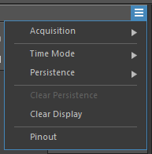
- After achieving reasonable waveforms on the oscilloscope for a 10 Hz, 200 mV input sinusoid, select the Acquisition option from the pull-down menu in the upper right-hand corner of the oscilloscope user interface screen and choose Acquisition 16 Averaged to reduce random measurement noise. Using the VirtualBench built-in oscilloscope waveform measurements, add a Peak-to-Peak Waveform Measurement to CH 1. The oscilloscopes automatic peak-to-peak measurement function does not work well on relatively small signals because of noise, and so use the waveform cursors instead to measure the CH 2 peak-to-peak voltage V_{in}. To do so set the cursor type as Voltage and position the two waveform cursors to provide the voltage difference ∆Y, that represents the average peak-to-peak voltage of the signal at V_{in} in Figure 4. Record this cursor measured peak-to-peak value as V_{in_p-p} in Table 1 below, adjusting the cursors as necessary for the different input frequencies. Also, for each input frequency listed in Table 1 below, record the CH 1 Peak-to-Peak Waveform Measurement as V_{out_p-k} in the table. While the VirtualBench Peak-to-Peak Waveform Measurement is not accurate for low-level signals, those automatic waveform measurements are sufficient for the V_{out_p-k} data to be included in Table 1, as relatively low-level V_{out_p-k} signals only occur for very low and very high frequencies. (Note: With 16 Averaged selected, it is necessary to wait several seconds after changing input frequencies for the oscilloscope to acquire 16 new measurements for averaging.)
- Complete Table 1 below for each of the input frequencies listed, adjusting the frequency of the FGEN output accordingly. Be sure to include units for V_{in_p-p} and V_{out_p-p} values, either by adding them once to each column label at the top or to each measured value. While the voltage ratio V_{out_p-p}/V_{in_p-p} is dimensionless, dB voltage gain assigns the unit dB to this dimensionless ratio. (Note: Instead of using the ratio of peak values for the voltage gain magnitude, a ratio of peak-to-peak values are used in Table 1, as they are easier to measure and yield the same results.) (13 points.)
- For the 10 kHz frequency data points, include an oscilloscope screen capture of your measured results, like the one shown below in Figure 6.

Table 1: Measured Data for the npn Common-Emitter Amplifier.
Input Frequency | V_{in_p-p} | V_{out_p-p} | |A_{v}| = V_{out_p-p}/V_{in_p-p} | ${\left|A_{v}\right|}_{dB}$¹
10 Hz | 194 mV | 362 mV | 1.87 | 5.42
30 Hz | 194 mV | 1.09 V | 5.62 | 14.99
100 Hz | 194 mV | 2.51 V | 12.94 | 22.23
300 Hz | 194 mV | 3.17 V | 16.34 | 24.27
1 kHz | 194 mV | 3.33 V | 17.16 | 24.69
10 kHz | 194 mV | 3.37 V | 17.37 | 24.80
30 kHz | 194 mV | 3.42 V | 17.63 | 24.92
100 kHz | 194 mV | 3.42 V | 17.63 | 24.92
300 kHz | 194 mV | 3.58 V | 18.45 | 25.32
1 MHz | 194 mV | 3.66 V | 18.87 | 25.51
2 MHz | 194 mV | 3.13 V | 16.13 | 24.15
5 MHz | 194 mV | 1.77 V | 9.12 | 19.20
10 MHz | 194 mV | 998 mV | 5.14 | 14.23
1 – $Voltage Gain Magnitude {\left|A_{v}\right|}_{dB}=20\log_{10}\left({V_{out_p-p}}/{V_{in_p-p}}\right)$.

- Based on your Table 1 data, plot the magnitude in dB on the vertical axis versus frequency on the horizontal axis, using a logarithmic scale for the frequency, which is a Bode magnitude plot. The MATLAB semilogx() plot command can be used to provide the logarithmic frequency axis scale if you choose to use MATLAB. Include the label “Frequency (Hz)” for the horizontal axis and “Gain Magnitude dB” for the vertical axis, along with the title “Gain Magnitude versus Frequency of a BJT Amplifier – Your Name or Names”. Replace the plot below with your version, keeping the figure number and caption. (6 points.)
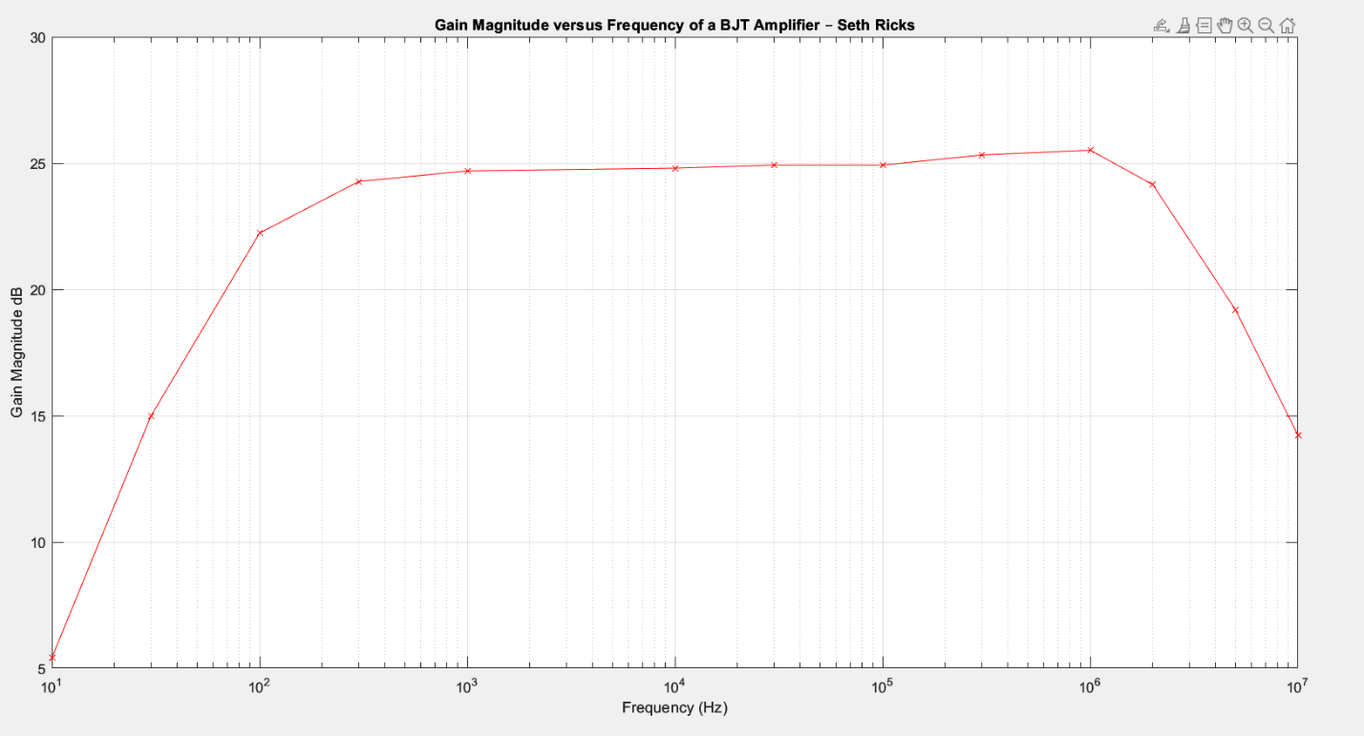
Figure 5: Frequency Response of the BJT Amplifier of Figure 4.

- Replace the BJT amplifier response at 10 kHz screen capture in Figure 6 below with your version, leaving in the figure number and caption. (6 Points.)
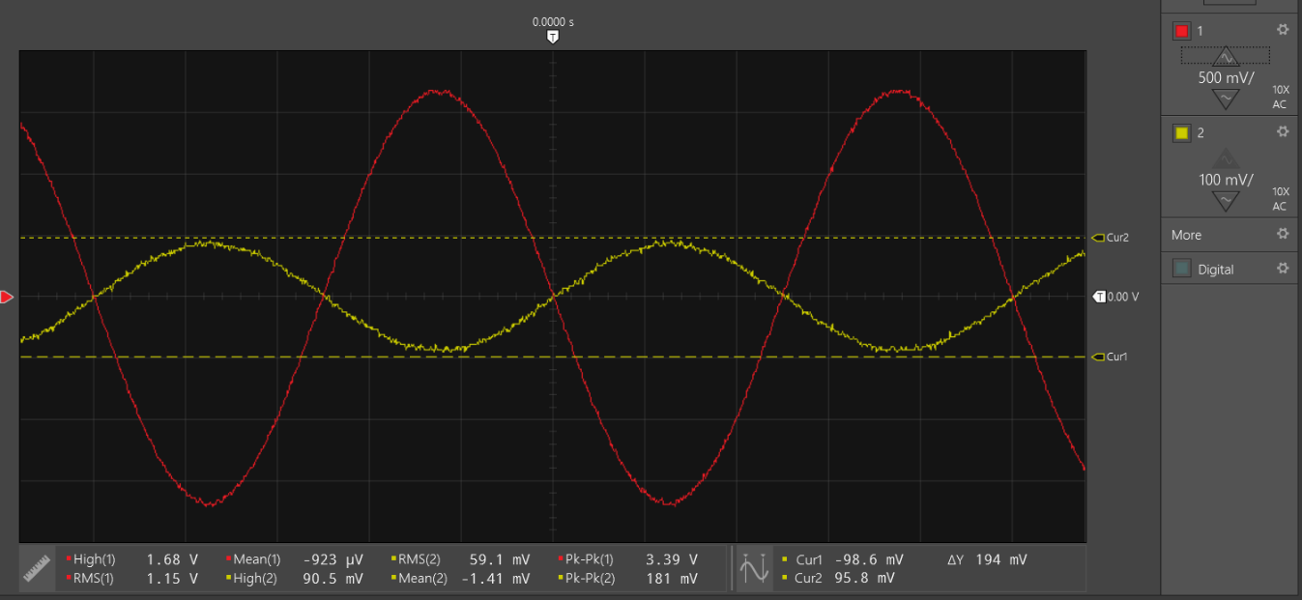
Figure 6: Input and Output Sinusoids at 10 kHz for the BJT Amplifier of Figure 4.

Discussion and Conclusions Questions: (For the following questions use your own words along with complete sentences. Points are to be deducted for AI generated answers.)

- Why is the calculated small-signal gain negative for the BJT amplifier circuit of Figure 4?
(2 Points.)

The signal gain is negative in this circuit because when the input signal increases into the base, the output signal decreases. V_{out} can be represented by:

$$V_{out}=V_{CC}-I_{c}R3$$

And so when the base current is higher, the transistor conducts more, so $I_{c}R3$ increases. Because $V_{cc}$ is constant, V_{out} decreases. Because of this inverse relationship, the small-signal gain is negative.

- For the BJT Amplifier Circuit of Figure 4, describe the function of capacitor C1, along with how the capacitor behaves at dc and the ac frequencies of interest. (3 Points.)
At ac the capacitor acts like a short, and at dc the capacitor acts like an open. Capacitor C1 in this circuit is in series with the ac source. This means that anything that is in series with the capacitor is filtered with respect to dc, and anything that is in parallel with the capacitor is filtered with respect to ac. Because capacitor C1 is in series with the signal source, it filters out the dc component of the source, bringing oscillation point of the signal down to 0 volts.

- For the BJT Amplifier Circuit of Figure 4, describe the function of capacitor C3, along with how the capacitor behaves at dc and the ac frequencies of interest. (3 Points.)
At ac the capacitor acts like a short, and at dc the capacitor acts like an open. Capacitor C1 in this circuit is in series with the ac source. This means that anything that is in series with the capacitor is filtered with respect to dc, and anything that is in parallel with the capacitor is filtered with respect to ac. Because the capacitor at C3 is in parallel with R4, this resistor is shorted out at ac. We need R4 because it still makes the capacitor $β$ independent, but we need to bypass it at ac to keep a higher gain.

LTspice Common-Emitter Amplifier Lab Grading Rubric: Submit an electronic version of a lab report to receive credit for doing this lab. The goal of your lab report is to provide sufficient documentation so that the lab can be repeated if necessary. Therefore, simply add to this document to arrive at your lab report, as all the explanatory text, procedures, and Discussion and Conclusion questions contained in this document are required for a complete lab report. So, for your lab report, add a cover page that includes name or names, class and name of the lab. Also add in your results, and answers to the Discussion and Conclusions questions to the existing lab document. While you are to share all Procedure items with your lab partner if you worked in a pair, your Discussion and Conclusions section is to be uniquely yours and not a copy of your lab partners.
Lab Report Item | Points
Cover Page | 2
Part 1 – Amplifier Hand Calculations.  Table 1: (12 points total. 2 points per entry, -0.5 points per missing units or sign error, with A_{v} being unitless.) | 12
Part 2 – AC Analysis.  Table 1: (13 points total. 0.25 points per entry, -0.1 points for each incorrect or missing unit.)  Figure 5: (6 points total. 2 points for using a logarithmic frequency axis, 1 point for using dB magnitude data from Table 1, 1 point for x-axis label including units, 1 point for y-axis label including units, 1 point for title including name or names.)  Figure 6: (6 points total. 4 points for correct looking traces, 1 point for voltage cursors attached to CH 2 V_{in} trace, 1 point for Pk-Pk measurement associated with CH 1 V_{out} trace.) | 25
Discussion and Conclusions | 8
Grammar and Professionalism | 3
Total | 50

Please give feedback on errors you find in this document.

